# Question #3

## DT Nonlinear Model

We simulate the nonlinear model using the ‘ode45()’ function on MATLAB. We define the nonlinear dynamics model function according to the code provided in Appendix C ‘NL_DynModel’. The resulting NL state dynamics simulation without process and measurement noise is shown in Figure 1. Here we set the initial state equal to:

|  |  |  |
| --- | --- | --- |
|  |  | ( 1 ) |

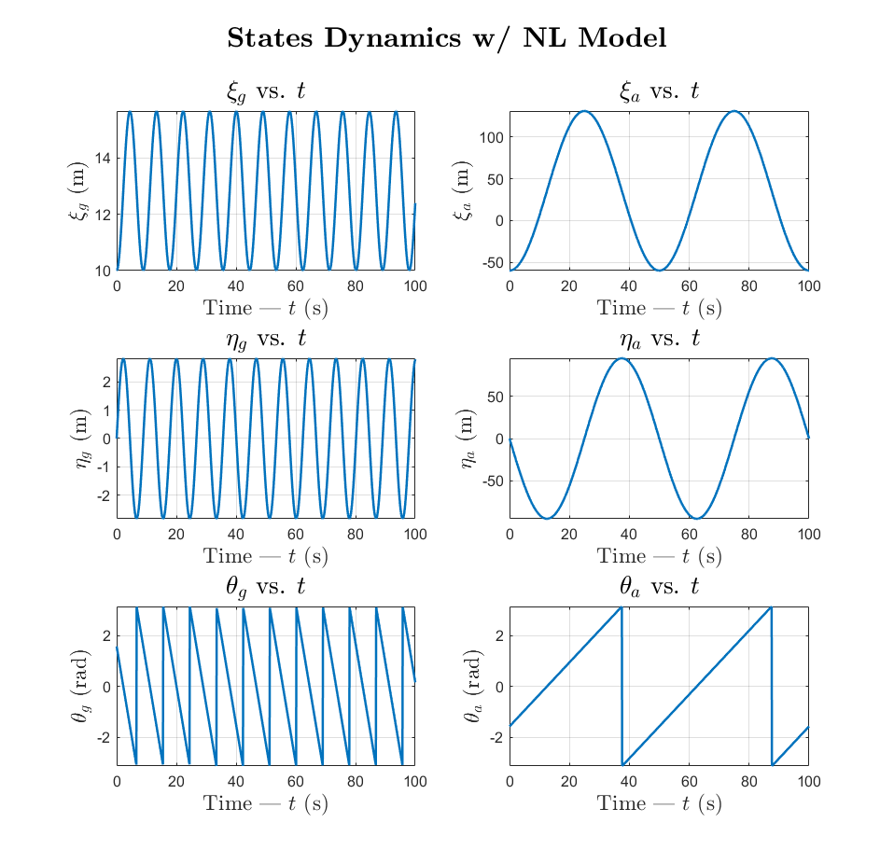

Figure – State dynamics simulation with nonlinear model (using ode45)

The nonlinear measurement model function is defined in Appendix C ‘NL_MeasModel’.

The resulting NL reading evolution without process and measurement noise is shown in Figure 2.

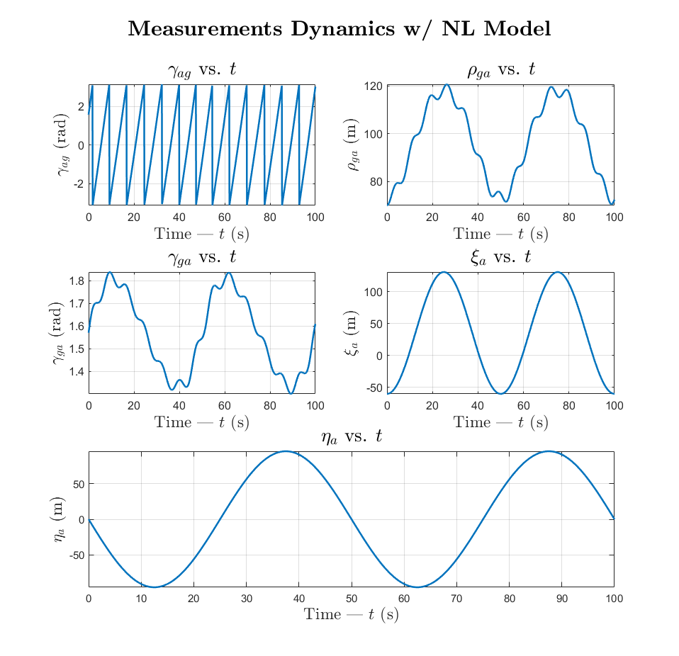

Figure – Measurement dynamics simulation with nonlinear model

## DT Linearized Model

We simulate the linearized DT model using the methodology prescribed in Question #1 and Question #2. In order to perform the linearization, we define the following:

|  |  |  |
| --- | --- | --- |
|  |  | ( 1 ) |
|  |  | ( 2 ) |
|  |  | ( 3 ) |

The transition matrices for the DT linearization model at step ‘’ are calculated in Appendix C ‘Linearize’ using and . The linearized state and measurement evolution as well as perturbations are calculated in Appendix C ‘DT_L_Model’.

The graph in Figure 3 plots the state evolution of the linearized DT model. Although the state evolution closely matches the NL model’s nominal trajectory, there is in fact a perturbation from the nominal trajectory shown in Figure 5. The graph in Figure 4 plots the measurement dynamics of the linearized DT model and the sensor readings perturbations are shown in Figure 6.

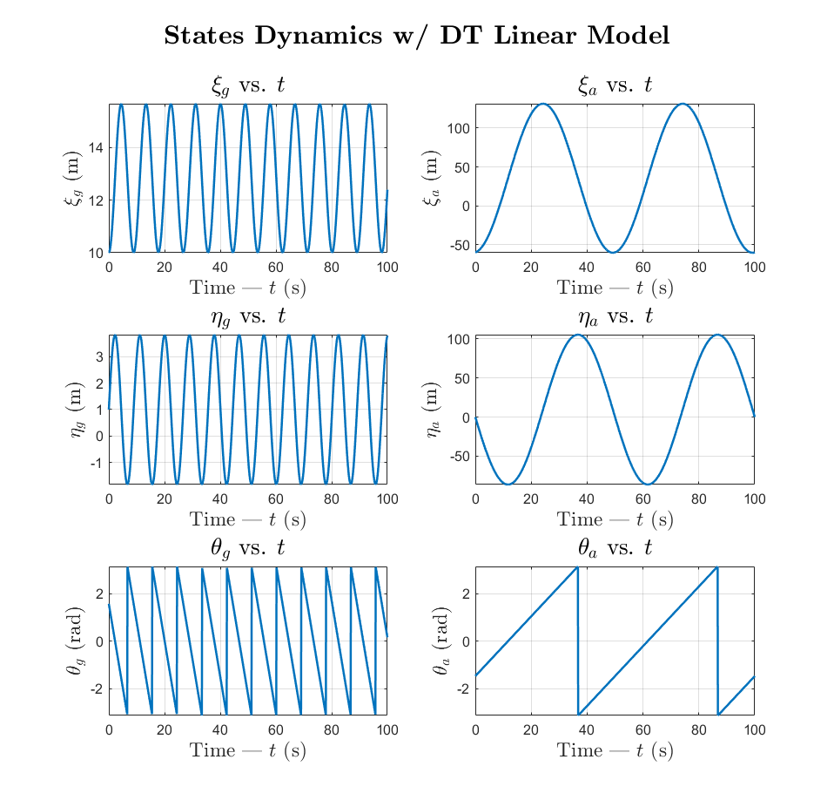

Figure – State dynamics simulation with DT linearized model

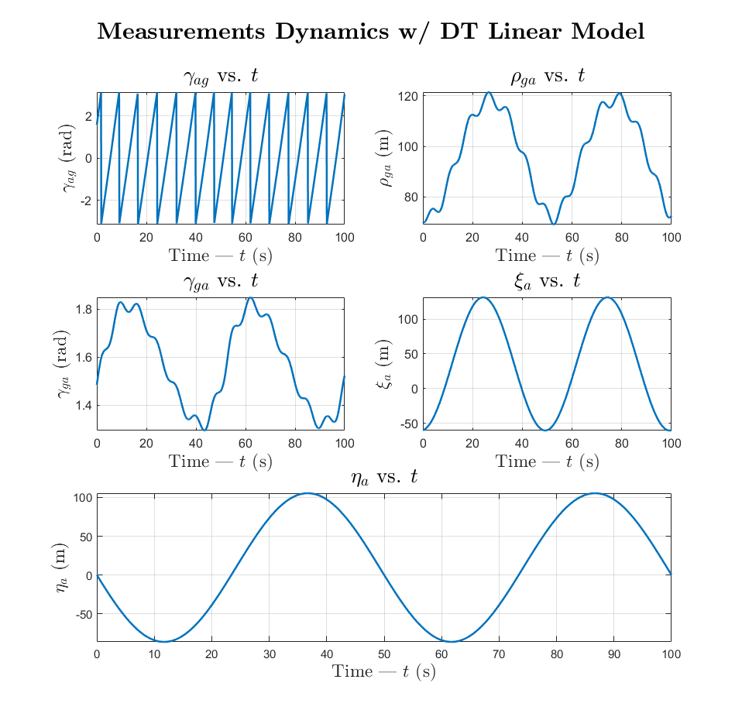

Figure –Measurement dynamics simulation with DT linearized model

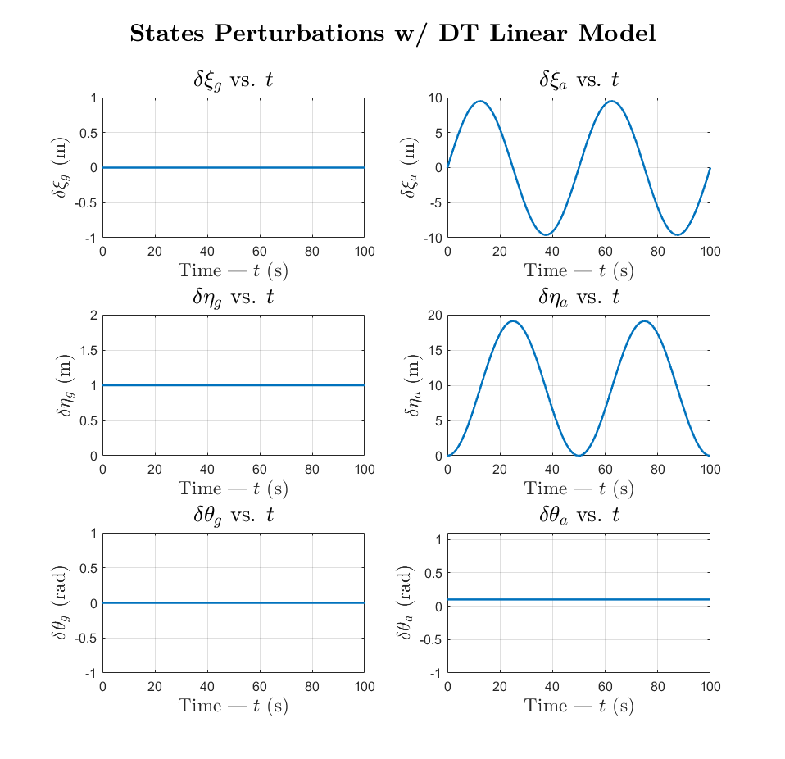

Figure – State dynamics perturbations with DT linearized model

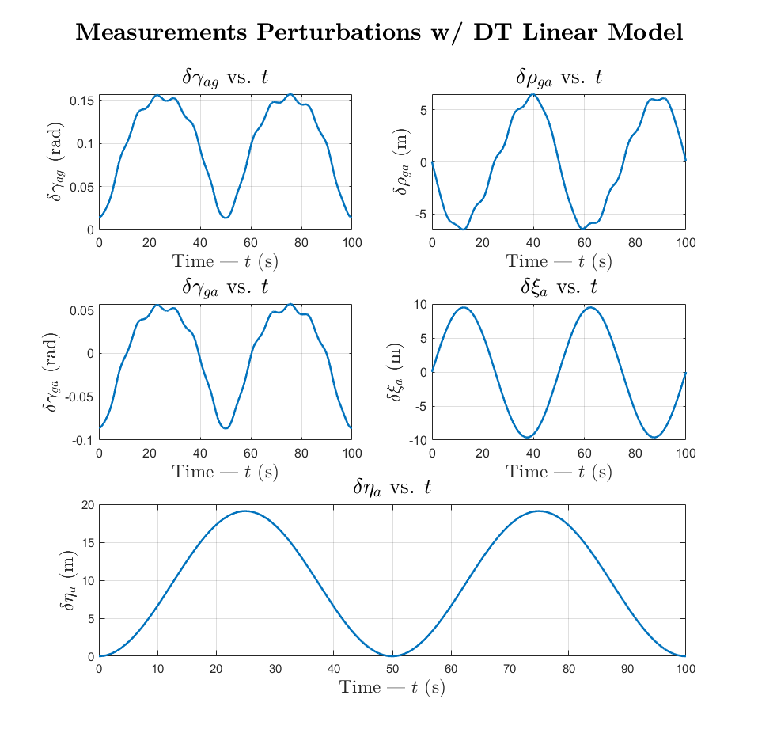

Figure - Measurement dynamics perturbations with DT linearized model\

The state perturbation graphs show that and are constant and unchanging while and are vary in an oscillatory manner. This perturbation is transferred through to the sensor readings as well as all the sensor outputs are calculated using and/or .

We can conclude that the linearization only results in major perturbation in the UAV’s states from their nominal trajectory while the UGV’s states deviate by a fixed value equal to the initial perturbation. And as a result, the sensor readings relating to UAV’s states contain major perturbations, while the relative sensor readings have a lower amplitude in their variation.